Dear Parents,
As we hit this ‘cold spell’ we thought it timely to remind you of our suggested kit for winter. Please could you ensure that your child has appropriate kit with them for our sessions. It is essential they have the correct kit as we go out whatever the weather, and remain outside for the whole session (approx two hours). It can get very wet and muddy and cold. They must have wellies/snow boots and waterproofs each week.

Essential kit each week
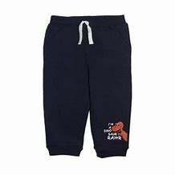
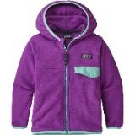
Old clothes- tracksuit bottoms and thick jumper such as a fleece to go on top of their leggings/vest/T-shirt/jumper
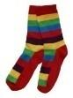
Extra pair of socks

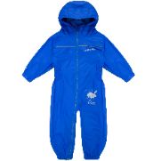
Waterproof all in one suit or trousers and a waterproof coat
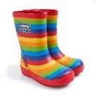
Wellies
A plastic bag or two to take home muddy clothes

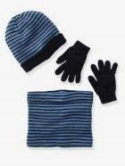
In very cold or very wet weather:

Hat, gloves, snood
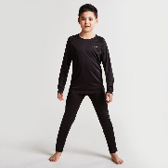
A warm base layer under clothing- leggings and long sleeve top (or some children may already have football skins or thermal base layers) (At least one of these layers, some of our Forest School Leaders wear up to 3 of these layers!)

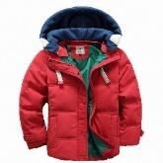
A thick winter coat to go under waterproofs

In very sunny weather:
A labelled bottle of suncream for self-application
A sunhat Thank you

