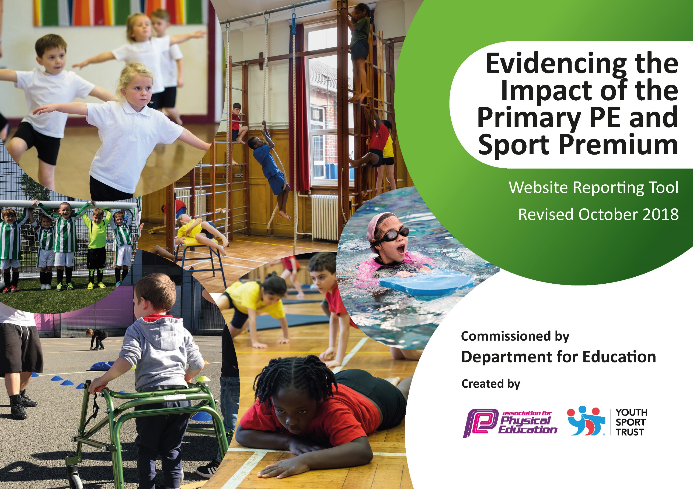
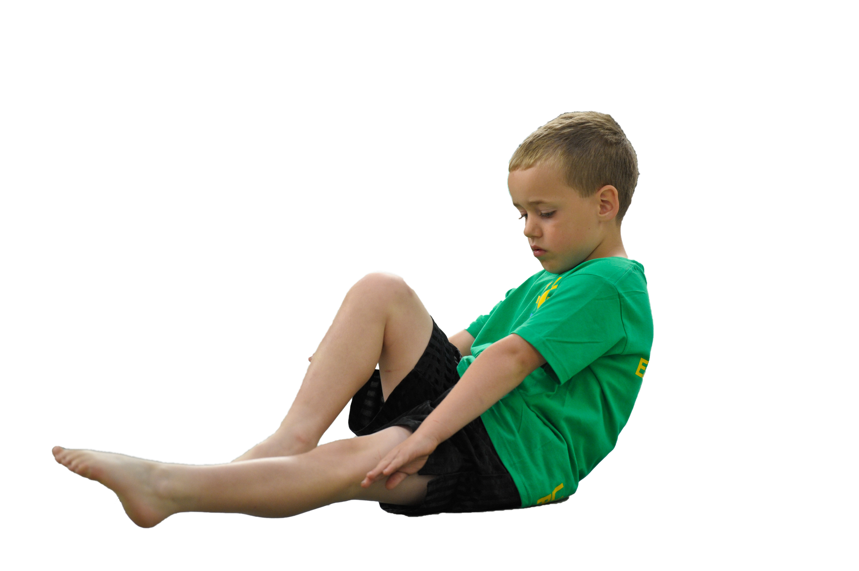
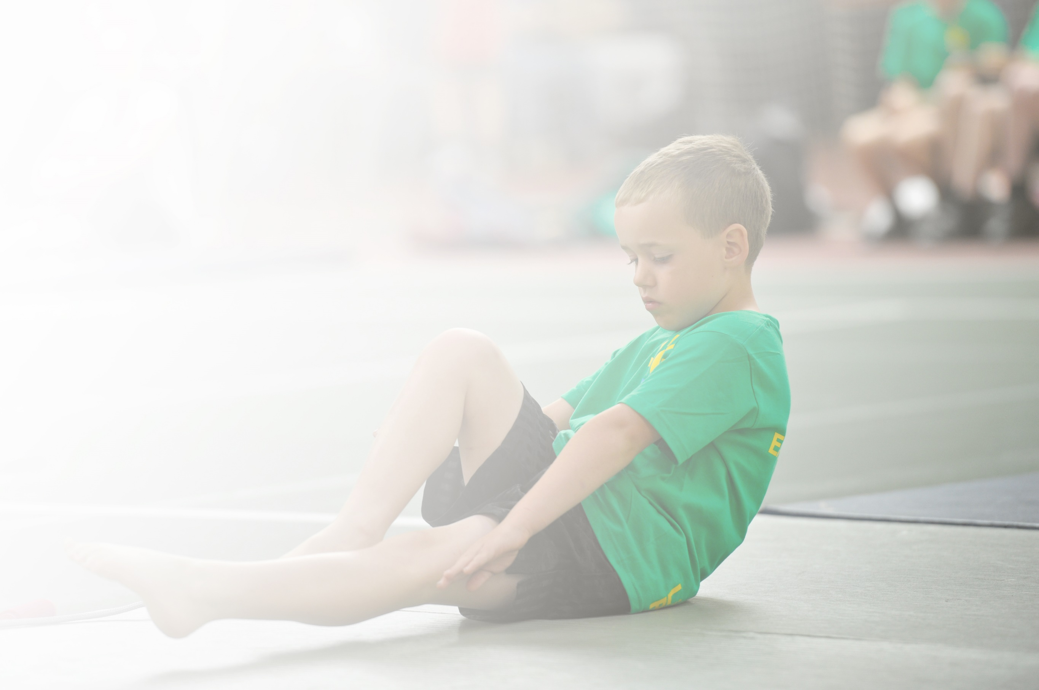
Schools must use the funding to make additional and sustainable improvements to the quality of Physical Education, Sport and Physical Activity (PESPA) they offer. This means that you should use the Primary PE and Sport Premium to:

- Develop or add to the PESPA activities that your school already offer
- Build capacity and capability within the school to ensure that improvements made now will benefit pupils joining the school in future years

Please visit gov.uk for the revised DfE guidance including the 5 key indicators across which schools should demonstrate an improvement. This document will help you to review your provision and to report
your spend. DfE encourages schools to use this template as an effective way of meeting the reporting requirements of the Primary PE and Sport Premium.

We recommend you start by reflecting on the impact of current provision and reviewing the previous
spend. Under the Ofsted Schools Inspection Framework, inspectors will assess how effectively leaders use the Primary PE and Sport Premium and measure its impact on outcomes for pupils, and how effectively governors hold them to account for this.

Schools are required to publish details of how they spend this funding as well as on the impact it has on pupils’ PE and sport participation and attainment by the end of the summer term or by 31 July 2019 at the
latest.
We recommend regularly updating the table and publishing it
on your website throughout the year, as evidence of your
ongoing review into how you are using the money to
secure maximum, sustainable impact. To see an
example of how to complete the table please
click HERE.

Support for review and reflection - considering the 5 key indicators from DfE, what development needs are a priority for your setting and your students now and why? Use the space below to reflect on previous spend, identify current need and priorities for the future.

Key achievements to date: | Areas for further improvement and baseline evidence of need:
- Participation in a wider range of sporting events (1st place in small school competitions)  - Wider proportion of children accessing sporting competitions (second and third teams)  - Staff confidence in delivering P.E increased from working alongside sports coaches.  - Number of children successfully and confidently swimming.  - Sports leaders continuing to improve active playtimes  - Achieved ‘Schools Games Mark Silver’ – summer 2019  - ‘Skip2bFit’ Day has resulted in improved resilience and growth mindset across the curriculum.  - 100% of all pupils have taken part in intra-school competitions through sports days, P.E lessons and lunchtime activities.  - 100% of KS2 pupils have taken part in out of school competitions. | - Invest in equipment to continue to develop active playtimes and the use of sports leaders.  - Approach specialist coaches to offer workshops in sports which the children would not normally be involved in (SGM priority)  - Offer out of school hour’s clubs to increase engagement of least active members of the school population (SGM priority)  - Review curriculum to ensure its in-line with delivery.  - Continue to offer staff CPD.

Meeting national curriculum requirements for swimming and water safety | Please complete all of the below:
What percentage of your current Year 6 cohort swim competently, confidently and proficiently over a distance of at least 25 metres?  N.B. Even though your children may swim in another year please report on their attainment on leaving  primary school. | 2018/19 Y6 cohort =22 pupils  100%
What percentage of your current Year 6 cohort use a range of strokes effectively [for example, front crawl, backstroke and breaststroke]? | 100%
What percentage of your current Year 6 cohort perform safe self-rescue in different water-based situations? | 15/22 = 68%
Schools can choose to use the Primary PE and Sport Premium to provide additional provision for swimming but this must be for activity over and above the national curriculum requirements. Have you used it in this way? | Yes

Action Plan and Budget Tracking
Capture your intended annual spend against the 5 key indicators. Clarify the success criteria and evidence of impact that you intend to measure to evaluate for students today and for the future.

Academic Year: 2018/19 | Total fund allocated: £16750 | Date Updated: July 2019
Key indicator 1: The engagement of all pupils in regular physical activity – Chief Medical Officer guidelines recommend that primary school children undertake at least 30 minutes of physical activity a day in school |  |  |  | Percentage of total allocation:
 |  |  |  | 10%
School focus with clarity on intended impact on pupils: | Actions to achieve: | Funding allocated: | Evidence and impact: | Sustainability and suggested next steps:
- Increased activity during school day  - Focus on active lunch time activities  - Better use of resources for playtime use  - HHS – REAL PE / Sports equipment | Monitor use of ‘Trim Tail’ & active play -  Sports Captains / MSA role to develop further as ‘play leader’  New Resources – link with pupil  Voice / school council  Skip2bFit workshop in school- 1 day to encourage children to be physically motivated. | £200  £200  £1095 | Children willingly and actively engage in physical activity in their own time. Basic equipment used at break and lunch.  Pupils from all year groups have the opportunity to access physical activity at lunchtime via the Sport Leaders.  Skip2bFit workshop allowed children to learn new skills and continue these skills at playtime.  Young sports leaders delivering quality activities for younger children. | Invest in new play equipment to continue to encourage children to be active at playtimes.  Further develop the leadership role of Y5/6 pupils.
Key indicator 2: The profile of PESSPA being raised across the school as a tool for whole school improvement |  |  |  | Percentage of total allocation:
 |  |  |  | 22%
School focus with clarity on intended impact on pupils: | Actions to achieve: | Funding allocated: | Evidence and impact: | Sustainability and suggested next steps:
- Celebration Assembly – ensures whole school and parents are aware of PE/Sport.  - HT report to FGB celebrates sport / PE  - Link to SDP action to improve resilience & growth mind-set. | Certificates and WOWS to celebrate achievement & participation.  Achievements shared on website and through newsletter.  Competitions organised through Harrogate Sports Partnership  Sports Instructor to develop PE/ Sport provision  Dance/Mvt sessions – teacher employed – 0.5 fte  ‘Skip2bFit Day’ to improve resilience and growth mindset. | No Costs  Costs included in KI 3  £3772.00  £200 (inc in KSI 1) | Higher proportion of children are motivated to compete in out of school and intra school sporting competitions.  Profile of P.E raised through participation in sporting competitions.  Participation in North Yorkshire Youth Sport Games marks significant achievements.  Skip2bFit workshop developed children’s understanding of resilience and increase in growth mindset.  Children have shared medals during celebration assembly in golf, swimming, cross country, tennis etc. | ‘Box2bFit’ Day to continue to encourage growth mindset and resilience in P.E  Continue to celebrate pupil’s achievements.  Invest in HSSP to continue to improve out of school competitions.

Key indicator 3: Increased confidence, knowledge and skills of all staff in teaching PE and sport |  |  |  | Percentage of total allocation:
 |  |  |  | 48%
School focus with clarity on intended  impact on pupils: | Actions to achieve: | Funding  allocated: | Evidence and impact: | Sustainability and suggested  next steps:
- Specialist PE Instructors to deliver quality PE sessions | Staff to work alongside P.E instructors to develop delivery of P.E curriculum.  Engage least active pupils in out of school hours learning. | 7 hrs per week includes planning& after school club  £8015 | Increased profile in sport & attendance at competitions  Delivery of P.E curriculum and confidence of staff increased.  Increase in children attending out of school hours learning. | Train new staff in skills.  Develop curriculum coverage, planning & assessment in line with new OFSTED Framework.
Key indicator 4: Broader experience of a range of sports and activities offered to all pupils |  |  |  | Percentage of total allocation:
 |  |  |  | 18%
School focus with clarity on intended  impact on pupils: | Actions to achieve: | Funding  allocated: | Evidence and impact: | Sustainability and suggested  next steps:
- Harrogate Sports Partnership membership  - Cluster sporting events  - Residential trips Y5/6 & Y3/4  Bi- Annual  2018 – Y3/4 – 2 days  2019 – Y5/6 - 5 days  - Pupil Sports Leaders | Involvement in competitions organised by HSP & subject leader support.  Take part in competitions & festivals  Timetabled throughout year  Take part in competitions & festivals – extra staffing  Transport costs  Additional Staffing  Involvement in physical activities – eg archery, canoeing, hill walking,  orienteering  Active involvement in Sports Days / playtimes.  Skip2bFit Day to include growth mindset / resilience etc | £1400  £705  £1000 | All children have taken part in a range sporting events  Team building opportunities and development in confidence  Achievements in out of school competitions- second round of competition and first time taking the children to the North Yorkshire School Games. | Continue to invest in partnership next year  Continue & develop  Investigate alternative sporting events from 2012 Legacy.  Investigate use of sports specialists to offer ½ or full coaching days to allow children to experience sports which they may not normally come across.
Key indicator 5: Increased participation in competitive sport |  |  |  | Percentage of total allocation:
 |  |  |  | %
School focus with clarity on intended  impact on pupils: | Actions to achieve: | Funding  allocated: | Evidence and impact: | Sustainability and suggested  next steps:
Engage in HSP events | Participate in festivals and competitions  Increase pupil participation in sports, including second and third teams.  Provide children the opportunity to participate in sports which they don’t normally participate in  Provide further opportunities for children to participate in future rounds of competitions if successful.  100% of KS2 children to take part in competitions.  100% of children to be involved in intra-school competitions through P.E lessons, sports days and at lunchtimes. | Costs included in other KI areas | Increased participation in sport – recorded on website  Participation in various sporting events throughout the year.  Teams in tennis, tri-golf and football achieving the second round of competitions.  Tri-golf team events in the Yorkshire Youth Sport Games in York.  Second and third teams involved in sports activities more throughout the year.  100% of KS2 children have taken part in competitions (cross country)  100% of all children have been involved in competitions (Intra school) through P.E lessons, sports days and at lunchtimes. | Continue involvement  Continue to offer second and third teams the opportunity to be involved in sport.

