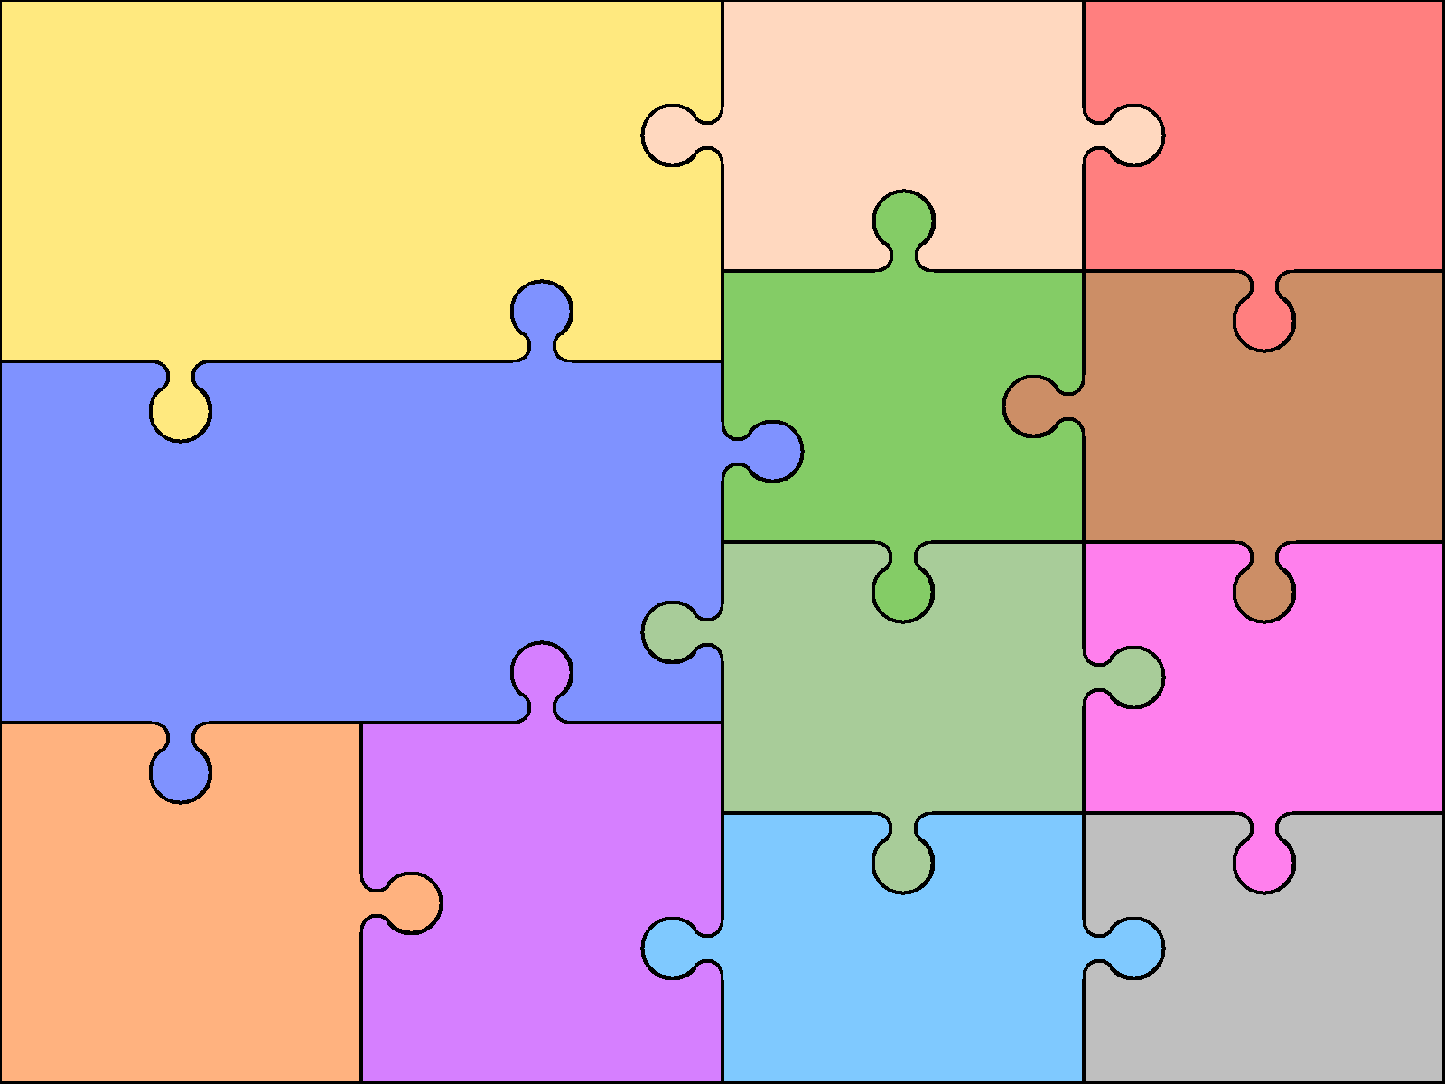

**Science**

Eco School

Seasonal Changes (ongoing)

Classifying animals - continued

Weather

Living things and habitats

Materials

**Grammar and Writing**

* Sentence structure and writing full sentences.
* Prefixes and suffixes.
* Subordinating conjunctions.
* Apostrophes for contraction and possession.
* Commas in lists.
* Writing in consistent tense.
* Plurals.

**English**

**Reading**

* Non-fiction and fiction texts.
* Inference skills.
* Using phonics to support reading.
* Sequencing parts of a story.
* Expressing views about different types of text.
* Comparing stories.

**Geography**

Locating countries on map

Locational and directional vocabulary

Maps of local area

Comparing UK to Australia

**PE**

Master basic movement, e.g. running, jumping, throwing, catching, balance, agility and co-ordination.

Participate in team games.

Perform dances using simple movement

**PSHCE**

Environmental issues

Differences

Growth Mindset

Practise makes perfect!

Teamwork

**Music**

Sing songs, play tuned & un-tuned instruments musically, listen & understand live and recorded music and make and combine sounds musically.

**History**

Local history

Captain Cook and Australia

**Art and Design**

Illustrations.

Outdoor art

Australian Aboriginal art

Drawing local landmarks/buildings/landscape

**Maths**

Revision

Time

Geometry – shape and position

Money

Capacity and Mass

**RE**

Special stories for Christians and Muslims.

Special places and traditions

**Design and Technology**

Shelters

Moving parts

**Computing**

Algorithms and instructions

Internet safety

Use computers to organise and store information

Word processing

Using computers to draw