This Photo by Unknown Author is licensed under CC BY-NC
TENNIS COACHING
HIGHSIDE PLAYING FIELDS-KIRKBY MALZEARD

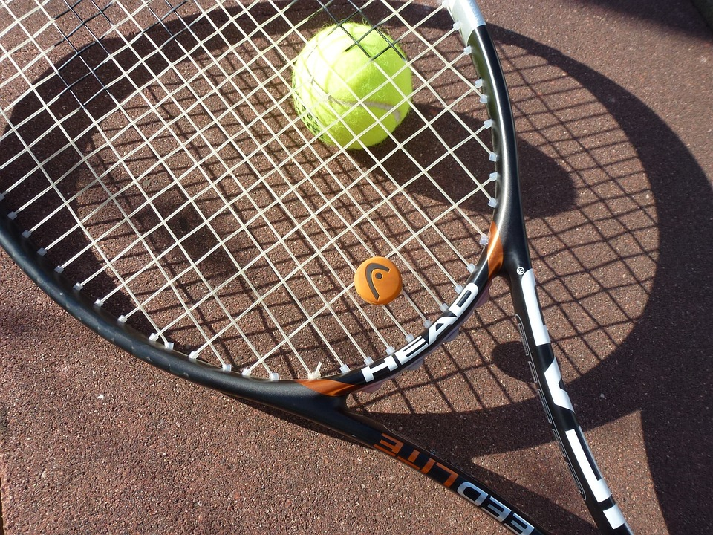

Starting Wednesday 17 April 2024
Hourly coaching sessions for children age 5 to 18
If you would like more information please email
gaynor.martin@ymail.com

